Patronage and Sponsorship Packages

October 2022 –September 2023

Message from The President

Gina Samuel-Richards
My Immediate Past President Matthew Olner enjoyed a very successful year for Leicestershire Law Society, with a full calendar of popular and well attended networking events and training courses, and raising a whopping £5,000 for his charity.
The LLS is recognised as being one of the most vibrant Law Societies in the England and I will seek to carry-on promoting its aims bringing in more members and delivering on growth.
This year, I have chosen to promote the work of 3 charities being: Focus, a young people’s charity; Zynthia’s Trust, a charity seeking to break the cycle of poverty for vulnerable women; and The Sickle Cell Society, a charity that supports and represents people affected by a sickle cell disorder to improve their overall quality of life.
My main focus will be connecting the youth of the county with a career in law. It is recognised that Leicester has a significantly larger young people population compared to the national average. It is therefore my wish to develop methods to connect with and tap into this talent for law in general and also the LLS and the business community.
I envisage building on legacy for the LLS and its members, and therefore I am seeking to have joint events with the Leicestershire Junior Lawyers Division, such as a Christmas party and panel discussions to promote legal education and careers. My other plans for the year will include the usual civic dinner, the magnificent LLS Awards, and the Garden Party.
One of the Society’s main aims is to serve its members by promoting Leicester as a centre of legal excellence. This aim can only be achieved year on year with the continued support and commitment of our Patrons, Business Partners and Sponsors. We therefore thank you for taking an interest in what we do and for considering supporting us.
Being a Patron of the Leicestershire Law Society provides you with invitations to attend our events and socialise and network with our lawyer members.
In addition, you have the opportunity to display your branding on all Leicestershire Law Society promotional materials, electronic mail outs and the website and the chance to place editorial in our Leicestershire Law Society Magazine and so forth.
We also welcome ideas from Patrons, Sponsors and Business Partners as to what we can offer you and how we can promote you to our members. I very much look forward to welcoming you as one of our new Patrons, Sponsors or Business Partners.
Gina Samuel-Richards
President of the Leicestershire Law Society
2022- 2023

Table of Contents

- About LLS

- Patronage Package

- Sponsorship

  - Networking Events

  - Specialist Events

  - Training Courses

  - Annual Dinner & Awards Ceremony

- Online Advertising

- Donate Charity Raffle Prizes

- Terms & Conditions

About LLS

Leicestershire Law Society (LLS) was established in 1860. Over 160 years it has grown from strength to strength and has a broad and varied range of individual solicitor, corporate and associate (barrister) members, based across the city and county. Its membership currently stands at around 800 members and it is recognised as one of the oldest and most active Law Societies in the country.
LLS prides itself on the active involvement and enthusiasm of its members at our many and varied networking events and training programmes throughout the year. The Society also works with Leicester’s two Universities, local businesses, other professional bodies and schools.
The traditional events, which include the Summer Garden Party, the Civic Dinner and the Annual Awards Ceremony to name just a few, are always well attended. The latter is held in conjunction with the local press and has excellent coverage.
All activities are well publicised on the website and with the help of social media such as Twitter, LinkedIn, Facebook and Instagram.
W: www.leicestershirelawsociety.org.uk
T: LeicsLawSociety
LI: Leicestershire Law Society
F: Leicestershire LawSociety
I: Leicestershire Law Society

The Society’s key Objects are to:

- Promote Leicester as a centre of legal excellence

- Through lobbying locally, regionally and nationally give a voice to our members.

- Be committed to promoting equal opportunities, diversity and human rights amongst the legal profession and those who employ their services.

- Provide social and business networking opportunities within and amongst the local profession and business community.

- Strengthen and develop relationships with local universities, schools and other professional bodies

- Strengthen the Society's profile in the local media

- Encourage a diverse mix of people at events that reflects the local legal profession in Leicestershire.

- Maintain and develop a healthy financial position to enable the Society to continue to evolve and develop

Patronage Package

Our commitment to our Patrons is to give exclusivity on patronage. We would not accept another patron in the same field as you during your time as a Patron of LLS*. Should you sponsor an event also that would give you exclusivity on sponsorship of that particular event within your field.
*IMORTANT NOTE: Your patronage does not give you exclusivity on an event or within the magazine unless you sponsor it at a separate cost.
The Patrons who support us benefit from the profiling generated amongst our membership and with all other parties and organisations that we deal with.

Annual Cost of Patronage is £3,000 plus VAT
This includes:
- Your logo on all correspondence/documentation/ flyers raised by LLS
- Your logo/corporate information displayed on tables at our annual dinner and all other events where appropriate
- A Vote of thanks at social events
- Information regarding all of our social events taking place where you can display publicity material where appropriate (e.g. pop up banners)
- Two free tickets for you to attend the traditional events being Shortlisting of awards, Civic Dinner and Annual Awards Dinner. Two free tickets each for two additional events of your choice during your patronage year.
- The opportunity to include an editorial in the LLS members’ magazine which has a circulation of 1000.
- Your Logo in the members’ magazine
- The opportunity to send mailings to our members through our electronic mail out system
- The opportunity to engage in additional high profile sponsorship at a reduced/discounted price. By way of example, this would include the Annual Legal Awards which would offer substantial press coverage with our associates, who are currently, Leicester Mercury.
- Badge – for events

In addition to the above, you will receive profiling of your firm on the LLS website to include:
- Your logo prominently displayed on the website
- Regular mentions through social media platforms
- A link to your website from that of LLS
- The opportunity to publish material about your organisation on the website, including topical/relevant articles
Furthermore, you will have:
- The opportunity to present to members of the LLS;
- The opportunity to run a training course to members of LLS;
- The support of the LLS to promote the course;
- The support of the LLS to arrange the venue and food, carry out basic administration and take bookings for your course;
- The opportunity to request a personal introduction to named delegates at LLS events. This will usually be done with the help of a member of the LLS Executive Board;

Finally, you will

- Receive an invitation to the LLS AGM.
- On prior request, receive one free parking space at LLS events.

Business Partners

The level of support to be provided will be agreed in a bespoke agreement with each Business Partner on a case by case basis.

- Your logo on selected correspondence/documentation raised by LLS
- A Vote of thanks at social events
- Information regarding all of our social events where you can display publicity material where appropriate (e.g. pop up banners)
- Two free tickets for you to attend our traditional events being Shortlisting of awards, Civic Dinner AND Annual Awards Dinner. You will receive two tickets each for two additional events of your choice during your year.
- The opportunity to engage in additional high profile sponsorship at a reduced/discounted price. By way of example, this would include the Annual Legal Awards which would offer substantial press coverage with our associates, who are currently, Leicester Mercury.

In addition to the above, you will receive profiling of your organisation on the LLS website to include:
- Your logo displayed on the website
- A link to your website from that of LLS

Furthermore, you will have:
- The opportunity to request a personal introduction to named delegates at LLS events. This will usually be done with the help of a member of the LLS Executive Board;

Finally, you will

- Receive an invitation to the LLS AGM.

Sponsorship

Sponsorship can open doors to important business opportunities.
These are just some ways in which sponsoring LLS events and courses could benefit your business:

- Gain immediate and direct access to senior lawyers, senior business professionals and key decision-makers in both the legal and business arena
- Obtain high profile, face to face exposure
- Generate new leads and clients
- Develop and consolidate relationships with current clients
- Develop new relationships with potential partners
- Introduce yourself as a thought leader by influencing the direction of your industry peers
- Market to a captive and targeted audience
- Increase your brand awareness

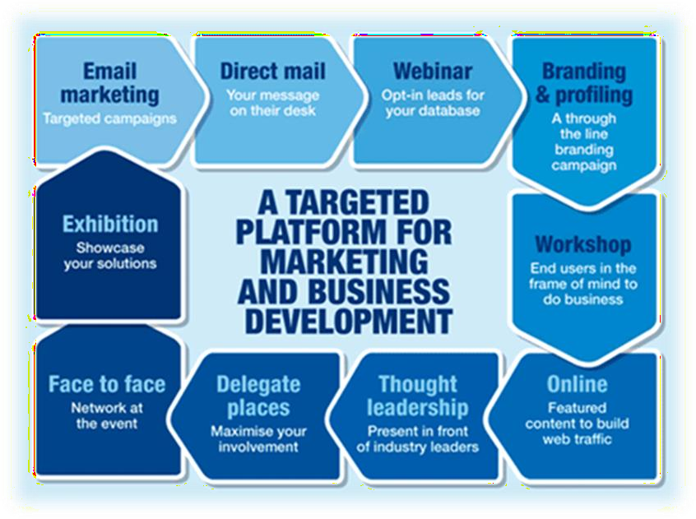

Sponsorship Package: Networking and Training Events

Package 1: Up to 50 people

The sponsorship package that we are offering for:

Headline Sponsor @ £800 plus VAT

- Raise your profile to LLS members and stakeholders
- Your logo on all correspondence/documentation raised by LLS in relation to the event named above, pre and post event
- Your name on pre and post communications relating to the event via our social network channels
- Invitation to attend the event and display publicity material where appropriate (e.g. pop up banners)
- Your logo prominently displayed on the LLS website Events page and a link to your website
- Your organisation’s name on the LLS home page: www.leicestershirelawsociety.org.uk
- Up to 3 free tickets to attend the event

Support Sponsor @ £500 plus VAT

- Raise your profile to LLS members and stakeholders
- Your logo on the LLS website in relation to the event both pre and post event
- Mention of your organisation via our social network channels
- Logo displayed on the LLS website Event page and a link to your website
- Up to 2 free tickets to attend the event.

Sponsorship Package: Specialist Events

Package 2: 50-200 people

The sponsorship package that we are offering for:

Headline Sponsor @ £800 - 1800 plus VAT Depending on event
- Raise your profile to LLS members and stakeholders
- Your logo on all correspondence/documentation raised by LLS in relation to the event named above, pre and post event
- Post event e-note via our mail out system to all attendees, with a link to your website to all LLS members
- Your name on pre and post communications relating to the event via our social network channels
- Invitation to attend the event and display publicity material where appropriate (e.g. pop up banners)
- Your logo prominently displayed on the LLS website Events page and a link to your website
- Your organisation’s name on the LLS home page: www.leicestershirelawsociety.org.uk
- Up to 3 free tickets to attend the event
- Any further information request received by LLS about your organisation from attendees will be forwarded directly to you.
- A special thank you at during the presidents (hosts) speech and a mention of your presence for those who may want to approach you

Support Sponsor @ £600 - £1200 plus VAT depending on event
- Raise your profile to LLS members and stakeholders
- Your logo on the LLS website in relation to the event; pre and post event
- Mention of your organisation via our social network channels
- Logo displayed on the LLS website Event page and a link to your website
- Up to 2 free tickets to attend the event
- A special thank you at during the president’s (hosts) speech and a mention of your presence for those who may want to approach you

Sponsorship Package: Annual Dinner and Awards Ceremony

Package 3: 200+

Headline Sponsor £3900 plus VAT
- Banner of LLS home page with link to your website
- Exhibitor space
- Your company profile included on the LLS website and link from the events page;
- A full page colour advert in our event brochure
- Your principal support recognised prominently on all the event marketing materials: starting from initial release of date- post event evaluation and press coverage.
(Note in certain cases there is only space for one logo and that will be yours, for example on our digital media channels)
- Free placement of your marketing materials for delegates
- Company logo on holding slides displayed in conference throughout the duration of the event
- 30 second digital advertorial played during the course of the evening on central and adjacent screens
- Recognition in the opening address and closing remarks
- Three free delegate passes with access to all areas (available to non- members of your choice)
- Complimentary parking
- Placed in the prestigious level of a Patron
- Pre-event view of guest list subject to GDPR requirements
- Opportunity to be personally introduced to three senior delegates of your choice
- Two complimentary places to attend LLS Civic Dinner
- Multimedia partner, placement on social media and digital channels

Awards Category Sponsors £2850 plus VAT

Prior to the Awards

- You will receive publicity on all publicity materials inviting nominations (subject to timing of your engagement with us);
- You will receive publicity at the short listing event, to include your logo on any promotional material and a mention at the event;
- You will receive an invitation (2 tickets) to the short listing event;
- You will receive two free tickets to the Annual Awards Dinner

During the Awards,
- Your organisation will be mentioned in the announcement;
- As the awards are presented, your logo will be on the main screen;
- You will be invited onto the stage to present the Award;
- Your photo will be taken and it may appear with a mention in the Leicester Mercury.

Examples of the awards are as follows:

- Senior Solicitor of the Year
- Junior Solicitor of the Year
- Paralegal of the Year
- Law Firm of the Year ( Small)
- Law Firm of the year ( Large )
- Legal Executive of the year
- Barrister of the Year
- Small Chambers of the year
- Large Chambers of the year
- Support staff of the year

Event Brochure £1500 plus VAT
- Pre and post event publicity
- 1 free ticket
- Logo branded on main screen during awards ceremony
- Featured logo in event brochure
- Half page advert in event brochure

Reception Drinks £1800 plus VAT
- Pre and post event publicity
- 1 free ticket
- Logo branded on main screen during awards ceremony
- Featured logo in event brochure
- Your literature in drinks reception area

Entertainment £2250 plus VAT
- Pre and post event publicity
- 1 free ticket
- Logo branded on main screen during awards ceremony
- Featured logo in event brochure
- Your logo branded on main screen during entertainment slots

Programme £1500 plus VAT

- Pre and post event publicity
- 1 free ticket
- Logo branded on main screen during awards ceremony
- Featured logo in event brochure
- Your logo branded on the event programme

Table display £1500 plus VAT

- Pre and post event publicity
- 1 free ticket
- Logo branded on main screen during awards ceremony
- Featured logo in event brochure

Advertising in Event Brochure Full Colour

£750 plus VAT Full Page

£450 plus VAT Half Page

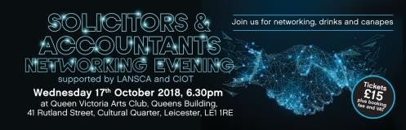
Online Advertising

Wider Coverage
The online advertising on the LLS website gives your adverts wide coverage. LLS currently offer three forms of online advertising.
- Job adverts
Under ‘Around the Firms’ then ‘Vacancies’ we can post job vacancies on our website for our member firms for the rate of £350 plus VAT. For non-members the rate is £475 plus VAT
Adverts will remain on our website for a period of 1 month, which can then be extended for a further fee depending on length of time required.

Word limits do apply, but there is the ability to link to your website and include files.
- Home page banner adverts
For the first year we are providing firms with the opportunity to place a banner on homepage of the website. The URL on this page generates the highest footfall. Your advert can be link to any page on your website.

Two week slot: £500 plus VAT Four week slot: £800 plus VAT
Advert designed by LLS: £60 plus VAT

For further information or specification please contact LLS on the details below.

We would of course be happy to discuss any of the above packages in more detail or to clarify any of the points highlighted as part of our packages.
In addition if you feel none of the packages meet your needs or you would like to tailor a package please do not hesitate to contact us.

Donate Charity Raffle Prizes

Each year, the President of the Society nominates his/ her chosen Charity to support that year.

You can help us donate funds for the charity at this difficult time by:-

1- Donating a prize that will be the subject of a raffle at one of the LLS events,

Or,

2- Become a sponsor for any of the events specifically being held to raise funds for the Charity.

Terms & Conditions of Booking

Your booking constitutes a formal agreement with Leicestershire Law Society to either become a patron, attend an event, exhibit at an event, sponsor an event as per the terms and conditions below. You will be accepting these terms and conditions at the time of booking/ making the agreement with us.

Your booking
For credit/debit card bookings your booking is confirmed once you have completed the relevant booking form and funds have been credited to our account. In the event that there are insufficient funds in your account to meet the booking value, we may not honour your booking. We reserve the right to charge you for any charges incurred where insufficient funds are available. You represent and warrant that the information you have provided in respect of your booking is correct.

Terms of payment
Full payment of the price advertised is to be paid at the time of booking or within 14 days of an invoice being issued. All costs attract the standard rate of VAT if applicable at the time of purchase. Purchase order numbers if applicable should be provided at the time of booking.

Methods of payment
Payment may be made to LLS by BACS transfer or by cheque. Cheques must be made payable to Leicestershire Law Society in pounds Sterling.

Cancellations, postponement and substitutions
Refunds for cancellation before the event will be subject to deductions as per our terms and conditions. Refunds for cancellation after the event will not be paid. Alternative delegates may be substituted for those already registered prior to or at the event at no extra charge.
A booking may be cancelled after payment has been made. Cancellations must be communicated to LLS in writing and we reserve the right to charge a cancellation fee as follows:
- If cancellation occurs 2 months prior to the event date, you will be charged 25% of the total cost.
- If cancellation occurs 1 – 2 months prior to the event date, you will be charged 50% of the total cost.
- If cancellation occurs between 6 and 8 weeks prior to the event date, you will be charged 75% of the total cost.
- If cancellation occurs less than 6 weeks prior to the event date, you will be charged 100% of the total costs.
We reserve the right to cancel any event. If this is the case, the full fee will be refunded unless a mutually convenient transfer can be arranged. In the event that we postpone an event for any reason and the delegate is unable or unwilling to attend on the rescheduled date, a full refund of the fee paid will be issued.
We will not refund any accommodation/travel expenses incurred by delegates if the event is cancelled or postponed.
We are not responsible for any loss or damage as a result of substitution, alteration/postponement of an event. We shall assume no responsibility whatsoever should the event be cancelled, rescheduled or postponed due to a fortuitous event, Act of God, unforeseen occurrence or any other event that renders running the event impracticable, illegal or impossible.
For reasons beyond our control it may be necessary to change the advertised programme content, timing and speakers or the event venue and location without any liability to the delegate whatsoever. Any substitutions or alterations will be updated on the relevant web page as soon as possible.

Liability
We do not accept liability for any injuries or losses of any nature incurred by delegates and/or accompanying persons, nor for the loss or damage to their personal belongings.
Please contact the Administrator at Leicestershire Law Society via email at office@leicestershirelawsociety.org.uk if you have any questions regarding these terms and conditions.

OUR AGREEMENT
PATRONAGE

I confirm that I have received a patronage package.
I confirm that the terms of the patronage agreement have been explained to me. I have agreed to become a patron for the agreed fee of £ plus VAT @ 20% = My patronage agreement with LLS will run from……………………to……………………..
The conditions of the patronage package together with terms and conditions have been explained to me and I have agreed to the terms as included in this patronage agreement/ document.
Signed……………………………………………………..
Dated………………………………………………………
Full Name……………………………………………….
Company………………………………………………….
Signed on behalf of LLS…………………………………………………………
Full name…………………………………………………………………………….

SPONSORING
I have chosen to sponsor the event of……………………………………………………………….
…………………………………………………………………………………………………………………………… taking place on…………………………………… The agreed fee for sponsorship is
………………………………………… plus VAT =……………………………………………………………..
The conditions of sponsorship have been explained to me. What I will receive for the agreed sponsorship fee has been explained to me as detailed in the agreement attached.
Signed………………………………………………………..
Dated………………………………………………………….
Full name……………………………………………………
Company name …………………………………………..
Signed on behalf of LLS ……………………………………………..
Full name…………………………………………………………….

